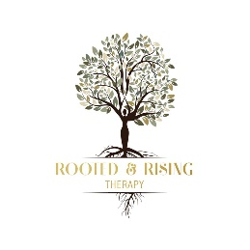 | 1 Altoona Place  Mt. Lebanon, PA 15017  412-228-8489  info@rootedandrisingtherapy.com

